Introduction

This manual is written to familiarize the end user with the structure and operation process of Sampling System for Urania plant.

The purpose of the Sampling System is to obtain and record mass spectrometry data, as well as oxygen concentration obtained by electrochemical sensor, from 16 different gas samples on Urania plant. The Sampling System is designed to work with minimal user interference for long amount of time.

This user manual, as well as software, is licensed under GNU GPL 3.0 license and can be used, copied, modified and reproduced by anybody.
Computer system

The sampling system is powered by personal computer on Debian - family Linux (more specifically, Zorin OS)/

The end user is not required nor expected to have any knowledge or experience of Linux system and terminal. However, typing primitive commands (that may be pasted from this manual) into terminal would be required. Brief instructions on terminal use are provided below:

Terminal can be opened either by Ctrl+Alt+T hotkey; or from launch menu (transparent “Z” letter in white hexagon in bottom left corner).

Commands can be typed into terminal either by keyboard or through Right Mouse Button menu. Ctrl+V hotkey do not work.

Commands are executed by Enter key. Command suggestions can be received by Tab key. Previously executed commands can be scrolled by up and down arrow keys.

For purposes of controlling mass flow controller; mass flow meter and pressure controller, additional computer called Vaccuum System Controller present in the system. It is connected to main computer and do not require user interaction for normal operation. However, it can be used to manually override the control of mass flow controller; mass flow meter and pressure controller.

Disclaimer: the program was tested only on Debian Linux systems. There are no guaranties that it will work properly on Windows, Mac, Arch, Fedora, FreeBSD and etc.

Principles of hardware operation

The system relies on MKS Cirrus 3 RGA (mass spectrometer) and Teledyne Instruments electrochemical oxygen analyzer for data collection; and on 16 – inlet valve and Vaccuum System Controller for sample management (introduction of sample to the system; change of sample and purging of previous sample). More descriptive flowchart provided below. Flowchart is explained on several pages below:

Electrochemical oxygen analyzer is added to the system as mass spectrometry produces M=16 peaks for both CO₂ (carbon dioxide) and O₂ (oxygen). Therefore, it was decided to add electrochemical sensor in addition to mass spectrometer.
First of all, gas enters sampling system through pipes marked by red rectangle (1).

Then, they pass through pressure regulators (PCV-1 to PCV-16) with pressure gauge (PT-2 to PT-17) attached. This part is marked with black rectangle (2). Gas exits pressure regulators through capillaries.

Then, gas passes through filters (F-1 to F-16). Filters have valves (V-4 to V-19 and V-20 to V-35) around them, so they can be changed without contaminaiting the system with atmospheric air. This part is marked with green rectangle (3).

Then, gas enters multi – inlet valve (MIV-1) marked with blue rectangle (4). Multi – inlet valve is explained on next page. MIV is surrounded by heat enclouse (HE-1) and is heated. Heat control is not required for current setup as there is an air conditioning in the building.

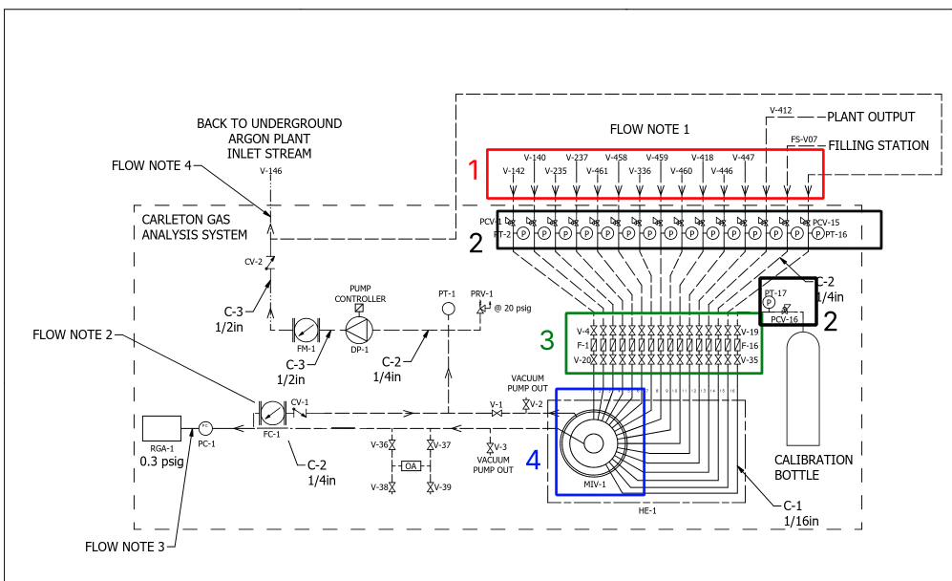

Multi – inlet valve (MIV-1), marked with blue rectangle (1) has two exits – sample line (marked with red rectangle 2) and common line (marked with green rectangle 3).

Currently scanned sample is directed to sample line. The rest of samples are flushed to the common line. Description of common line and of purging is given in next paragraph.

The purpose of the Sample Line is to guide pure sample of gas to sensors (RGA and OA).

There are two scanning devices in Sample Line – Residual Gas Analyzer (RGA-1, marked with black rectangle 6) and Oxygen Analyzer (OA, marked with magenta rectangle 4).

RGA is connected to the system through Pressure Controller (PC-1, marked with yellow rectangle 5), to stabilize the input pressure to 760 mmHg.

There are 5 valves in the system (marked with cyan rectangles 7). They are added to the system for leak checking and other technical purposes. During normal operation, V-36 and V-37 are always open and V-38, V-39 and V-3 are always closed.

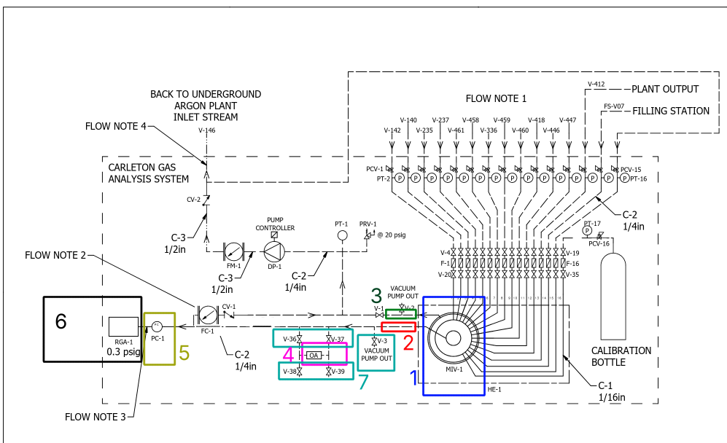
!!! Exposure of oxygen analyzer to atmospheric air may damage the sensor !!!

The purpose of the Common Line is venting samples that are not currently scanned back to the plant, as well as purging Sample Line during sample change process.

Sample Line is connected to Common Line with Mass Flow Controller (FC-1) and one-way valve (CV-1). During purging process, MFC is open to vent previous sample out of the Sample Line, and displace it with the new sample. During scanning process, FC is closed to build enough pressure in the Sample Line. One – way valve is required to prevent gas in Common Line from entering Sample Line in case of pressure surges. This part is marked with blue rectangle (1).

Gas is vented from the sampling system back to the plant using vaccuum pump (magenta rectangle 4). Part of it is vented back to sampling system. To prevent gas from flowing back in cas of pressure surge, one-way valve CV-2 (marked with black rectangle 7) is used.

Pressure gauge (PT-1, red rectangle 2), emergency pressure release (PRV-1, green rectangle 3), and Mass Flow Meter (FM-1, yellow rectangle 5) present in the system.

Just like in the Sample Line, there are 2 valves in the system (marked with cyan rectangles 6). During normal operation, V-2 is closed and V-1 is open .

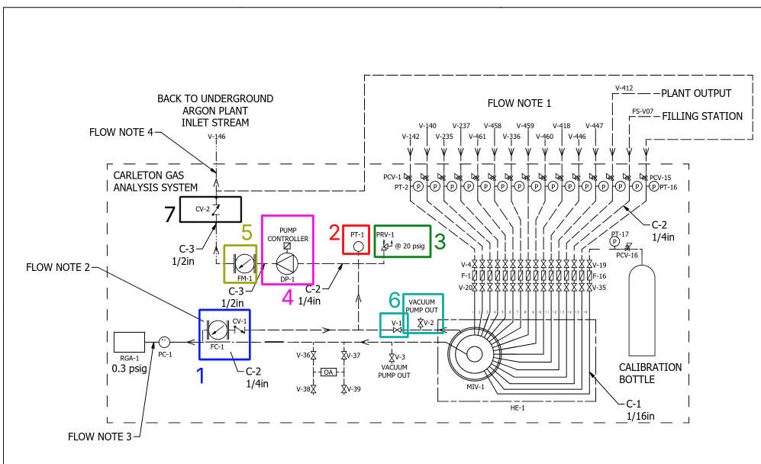

Hardware visual appearance

Although flowchart in the previous chapter describes the way hardware works, it is an abstract scheme that looks different from real hardware. This chapter describes how real system looks like.

Flowsheet is split into eight areas and for each one a photo with ID’s of elements is provided.

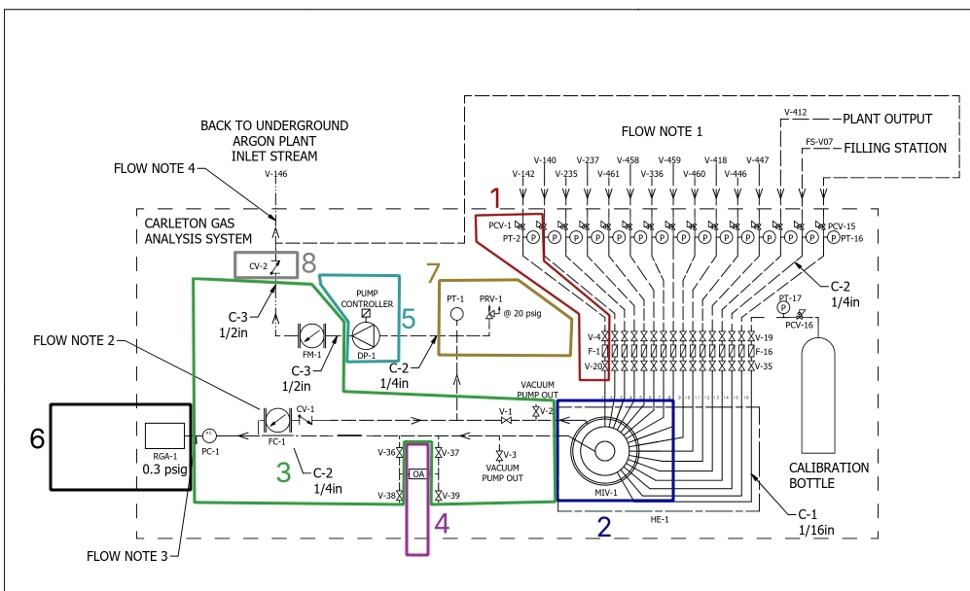

Area 1:
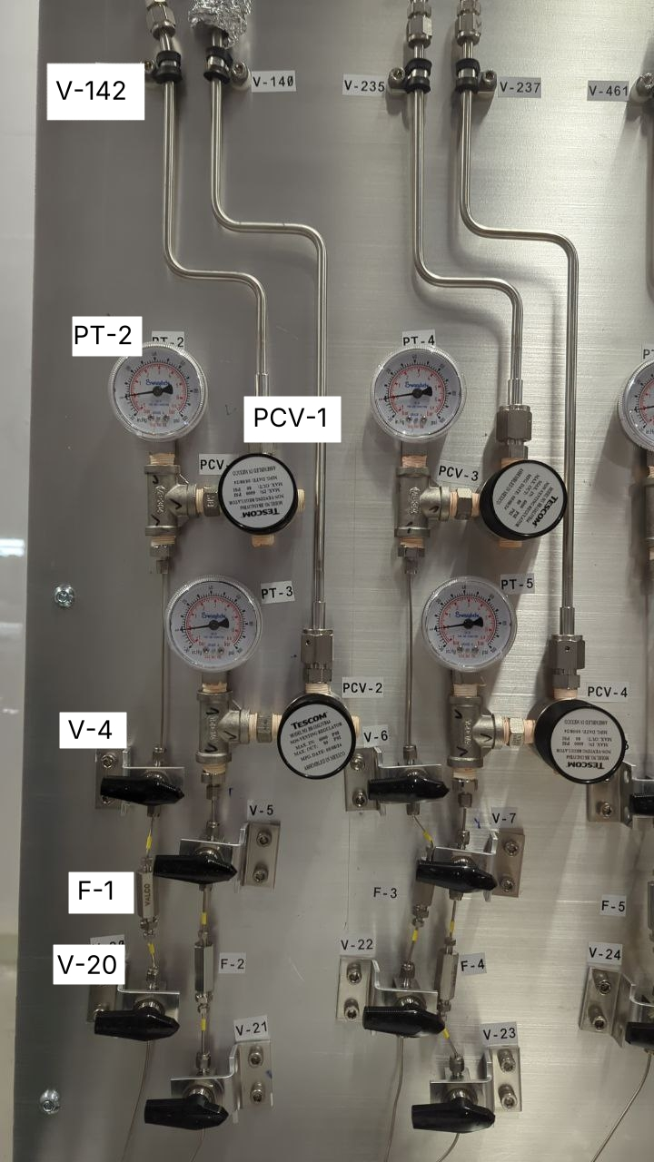

Area 2:

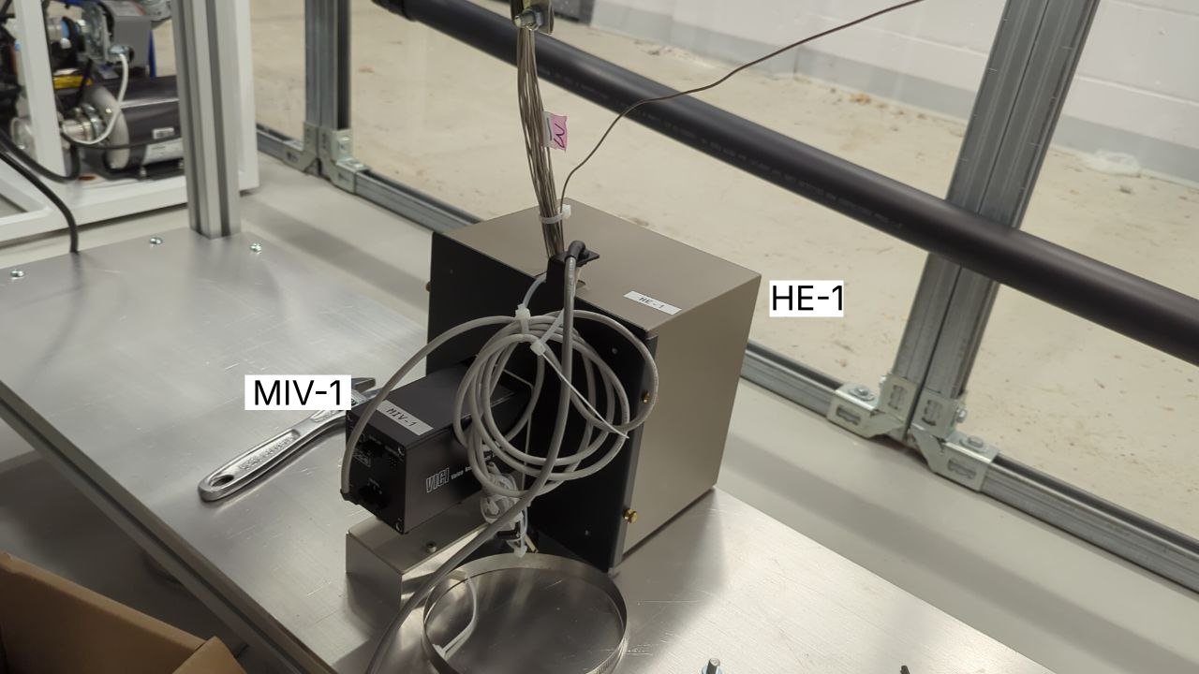

Area 3:

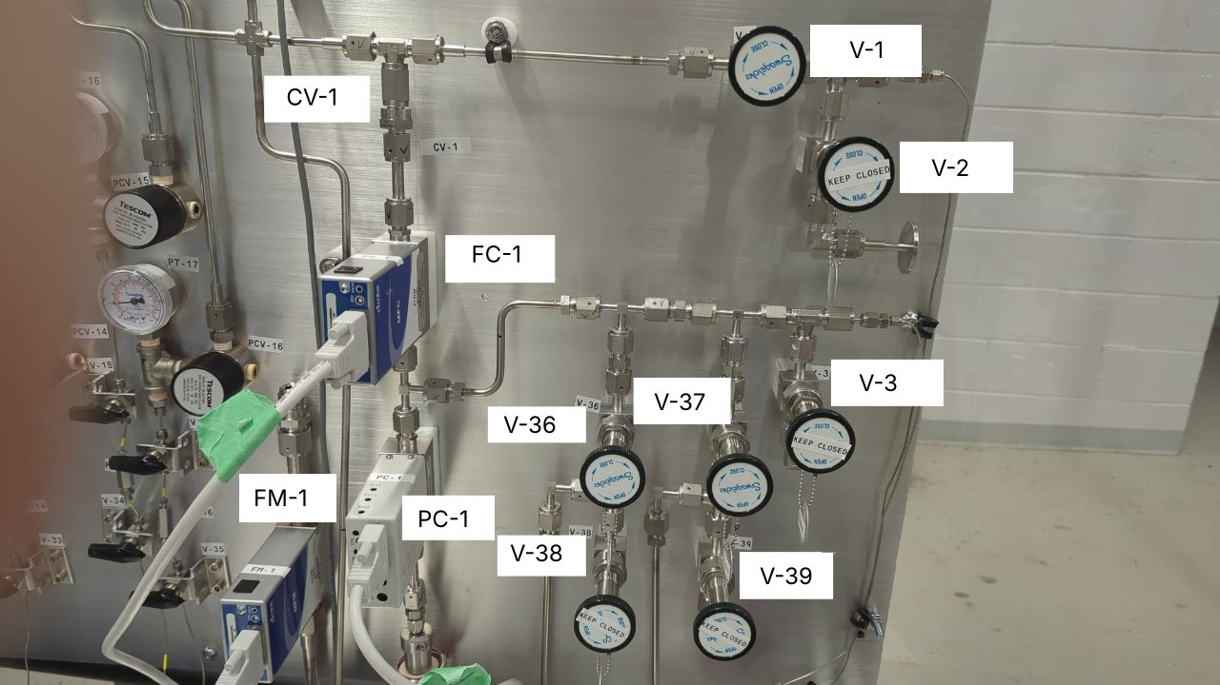

Area 4 (front and rear view respectively):

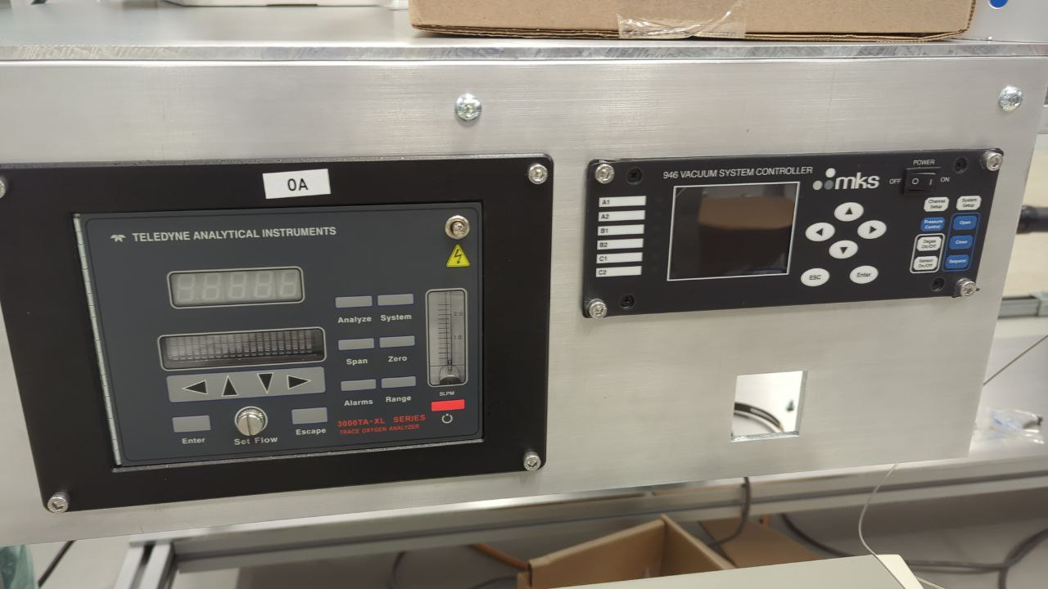

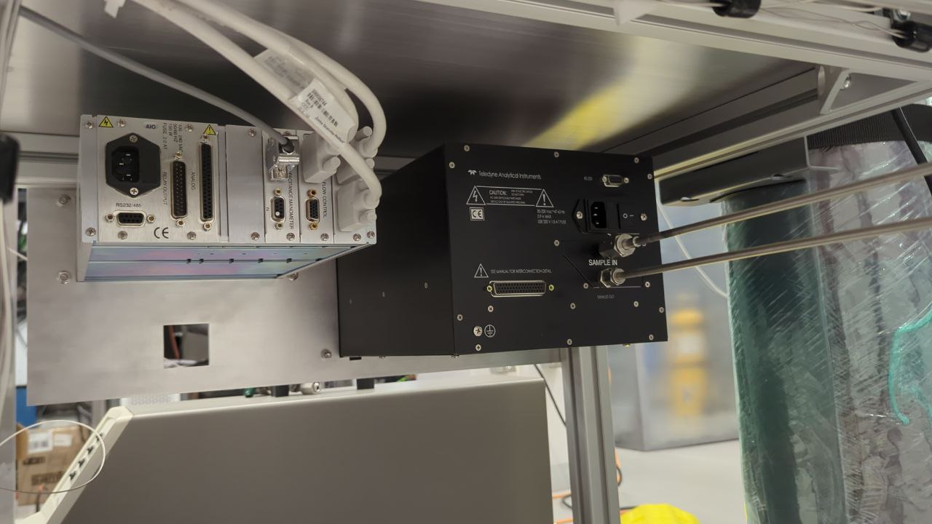

Area 5:

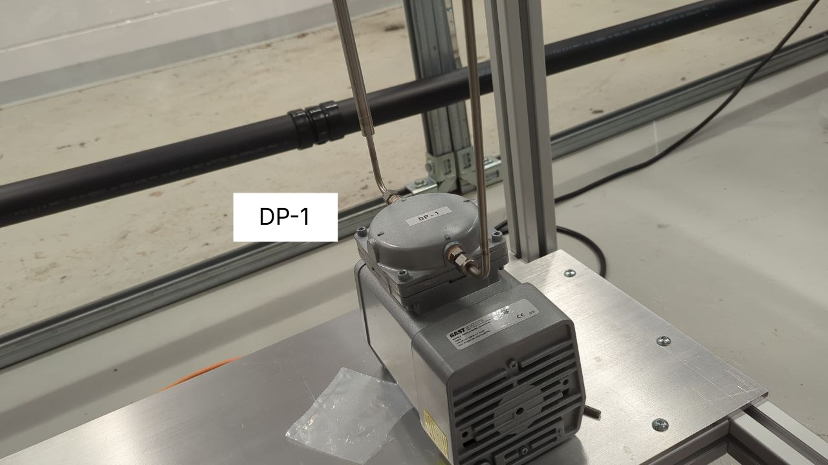

Area 6:

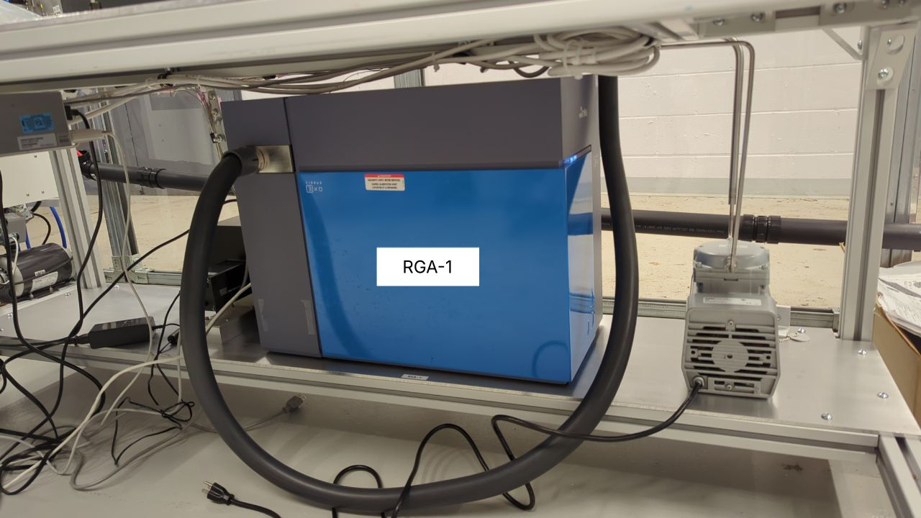

Area 7:

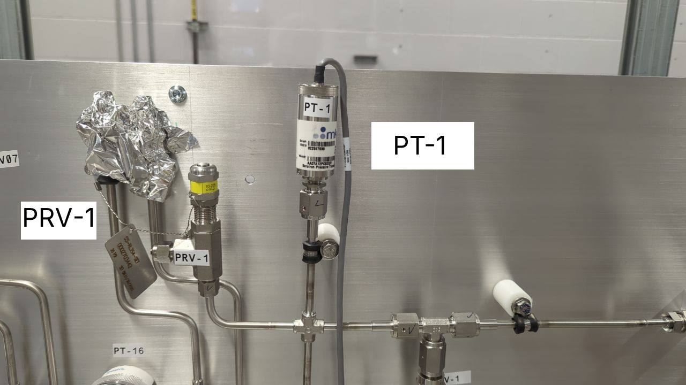

Overall view:

File structure

The file is where the recorded data is stored. Single file is designed to store data recorded under uniformal conditions (in other words, obtained from the same sample pipe and under the same configuration of RGA and vaccuum system).

File is stored directly in Urania directory.

First line of file (metadata) contains technical parameters of the scan:

1) Number of sample to be scanned (from 1 to 16)
2) Span of molar masses to be scanned (3 values are stored: initial molar mass, amount of molar masses scanned and step between adjacent molar masses)
3) Duration of purging in seconds; and duration of calmdown in seconds (purging is described in Hardware chapter)
4) Flow through Mass Flow Controller in cm³/min (from 20 to 1000) during purging; or during calmdown. “open” or “close” may be specified instead of number, to have unrestricted or zero gas flow respectively.

Other lines contain an individual measurement: moment of time measurement was taken at (in seconds since 01 Jan 1970); span of data obtained from mass spectrometer (in Pascals); and oxygen concentration in PPM.

Execution flow of program

The program works cyclically; and the execution flow works the following way:

1) Task is selected, as described in Data Collection chapter. Information about the task (amout of measurements, sample number, purging parameters and etc.) is copied to be used later.

2) Multi inlet valve is switched into selected position, so that required sample is flowing into RGA.

3) Purging process starts: mass flow controller is opened for designated amount of time, so that new sample can displace the old one.

4) Calmdown process starts: flow through mass flow controller is stopped (or reduced) to stabilize the pressure before taking measurements.

5) Mass flow controller is closed and pressure flow to RGA is set to 760 mmHg. Data is inquired from RGA and from oxygen analyzer; and saved to data file specified for current task.

6) Execution is repeated since step 1. Different task would be selected, and measurements would be taken for different parameters.

Installation

To download the program, make sure Git version control system is installed on your machine. You can install Git by typing following commands:

sudo apt update && sudo apt upgrade && sudo apt install git
cd Desktop
git clone https://github.com/DaniilKorshkov/Urania

Make sure Python3, pip and following Python libraries (streamlit, matplotlib, pandas, pyserial, pyusb, pyvisa, python-netdiscover) are installed on your system under superuser privileges. Make sure Netdiscover is installed on your system:

sudo apt install python3
sudo apt install python3-pip
sudo apt install netdiscover
sudo pip install streamlit
sudo pip install matplotlib
sudo pip install streamlit
sudo pip install pandas
sudo pip install pyserial
sudo pip install pyusb
sudo pip install pyvisa
sudo pip install python-netdiscover

This chapter should already be performed before shipping, however, it is included just in case.

Hardware setup

Before starting the sampling process, following procedures with hardware should be performed:

1) RGA-1, Vaccuum system controller, oxygen analyzer (OA), multi-inlet valve (MIV-1), vaccuum pump (DP-1) and personal computer are connected to power supply and turned on.

2) Make sure that pump DP-1 is running smoothly and not stalling.

3) Valves V-1, V-36 and V-37 are opened. Valves V-4 – V-35 are opened. Valves V-38, V-39, V-2 and V-3 are closed.

Opening of valves V-38 and V-39 should be performed only if oxygen sensor is removed and sealed in oxygen-free environment. Valves V-2 and V-3 can be opened only if valves V-36 and V-37 are closed, or if oxygen sensor is removed. !!! Failure to do so may lead to permanent damage of oxygen sensor !!!

Start the web application

1) User interface of the program works through web application

1.1) To start the web app, navigate to Urania directory and start the webapp by typing following command. Enter admin password as prompted

cd Desktop/Urania
sudo streamlit run main.py

1.2) Open any web browser (firefox and brave were tested) and navigate to localhost:8501 address. If done correctly, program welcomes you with the following menu:

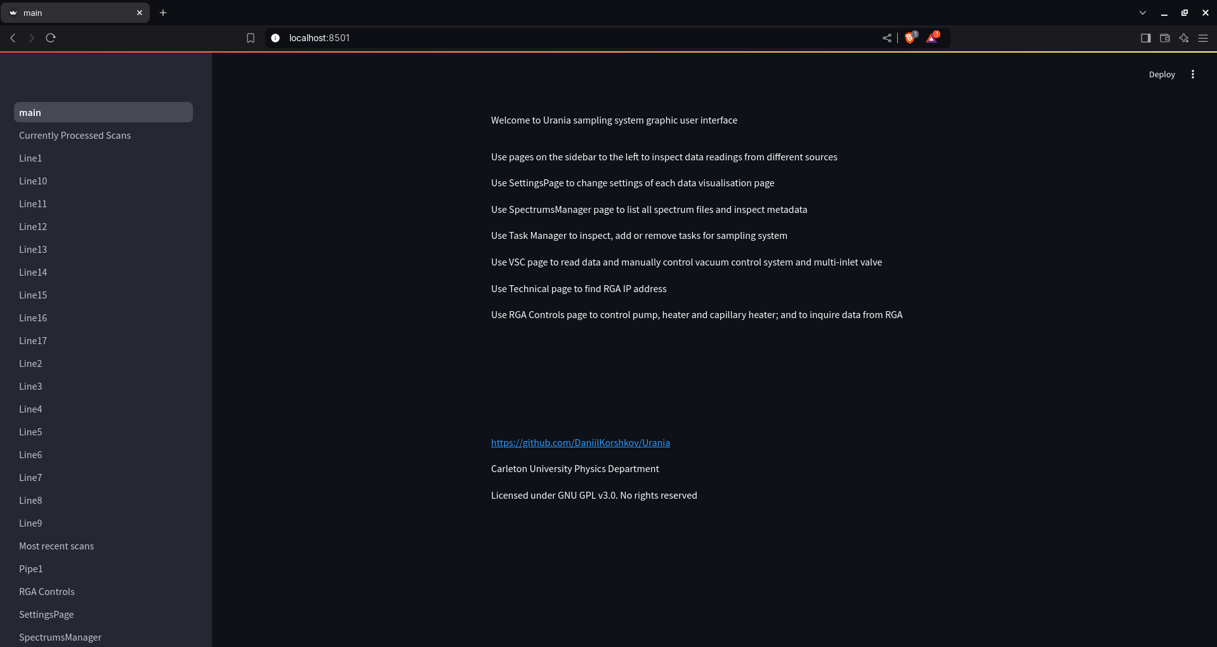

Data collection

1) Navigate to SpectrumsManager tab with the menu on the left, and create empty spectrum file

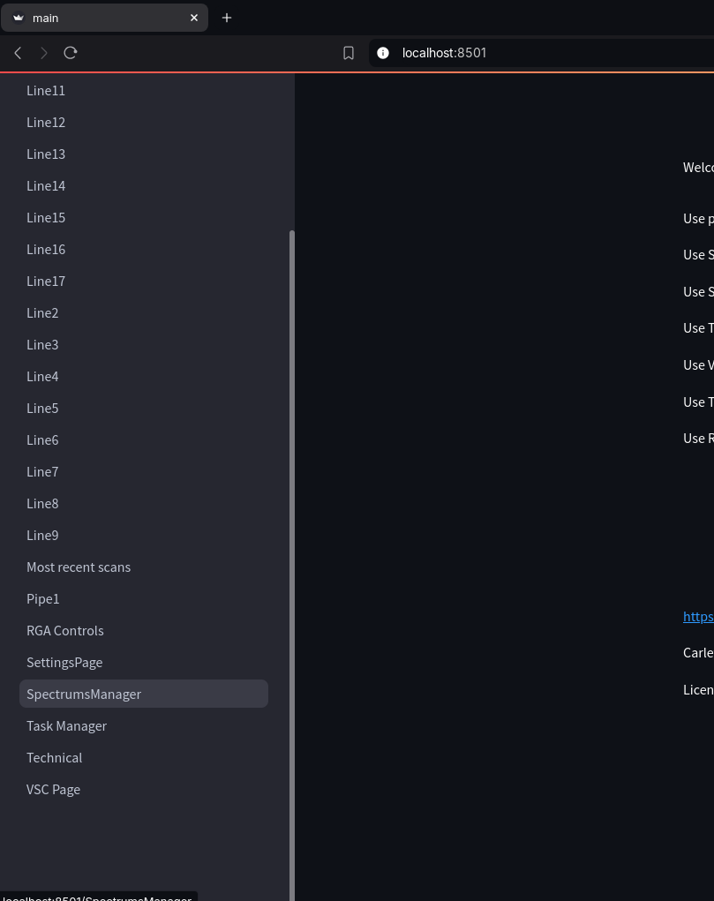

1.1) Scroll down to the bottom of the page, specify filename, multi inlet valve position from 1 and 16, initial M, step, amount of steps and purging parameters:

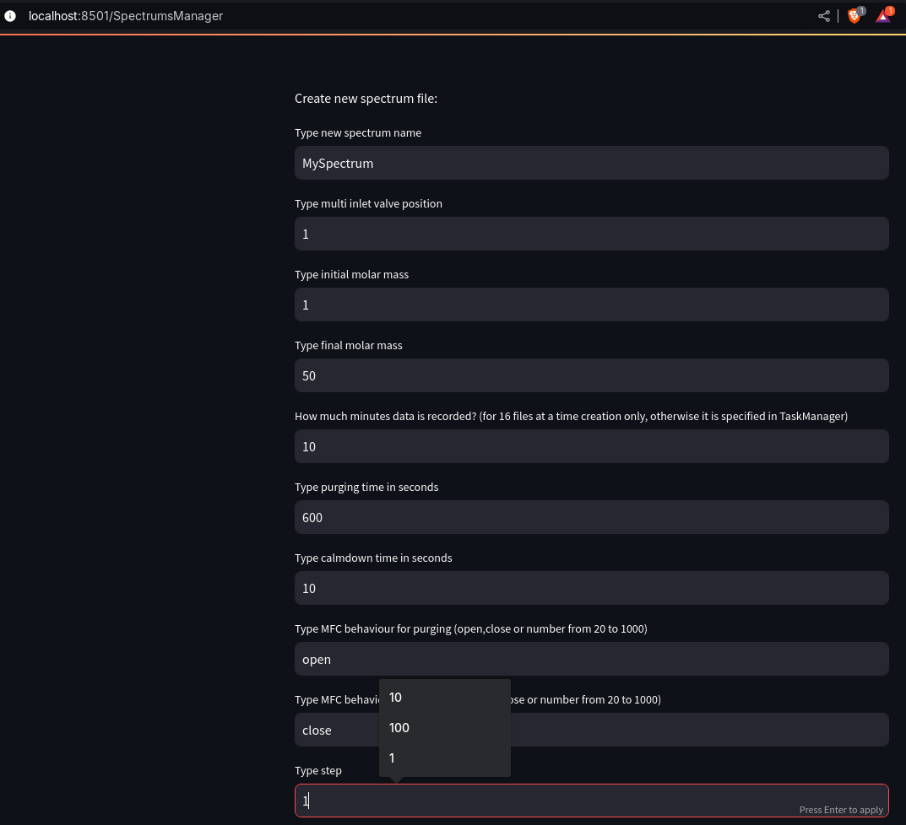

1.2) Press “Create Spectrum” button to create 1 spectrum; or press “create 16 equivalent spectrums and corresponding tasks” to create 16 spectrums (with multi inlet valve position from 1 to 16) and 16 correspoding tasks. If done so, you can skip step 2

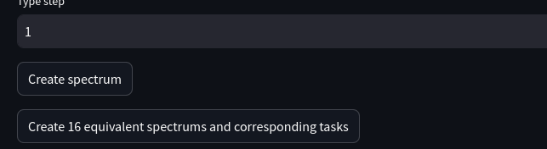

2) Create a task in Task Manager page of web app

2.1) In the bottom of the page, select type of the task (emergency, scheduled or regular)
2.2) Specify unique task name, multi inlet valve position from 1 to 16, filename of spectrum and amount of scans
2.3) If task type is emergency, specify the amount of executions – either integer or “inf”. If task is scheduled, specify the frequency of executions (for example, if freq=3600, task would be executed once every 3600 seconds)

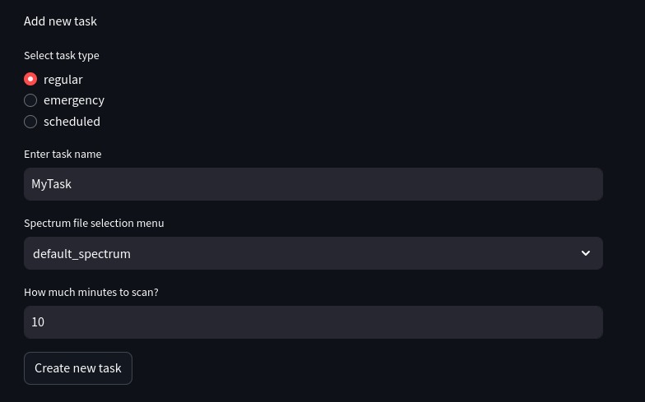

Priority of task execution is determined the following way:
1) If there is an emergency tasks the in list, first emergency task encountered is executed
2) Else, if there are scheduled tasks in the list, first scheduled task that wasn’t executed on time, would be executed (for example, task with freq=3600 that was executed 3800 seconds ago)
3) Else, regular tasks are executed in alternating manner (for example, task1, then task2, then task3, than task1 if there are 3 tasks in the list)

2.4) You can use menu to move tasks up, down or delete. If web page is not responsive, reload page after pressing button

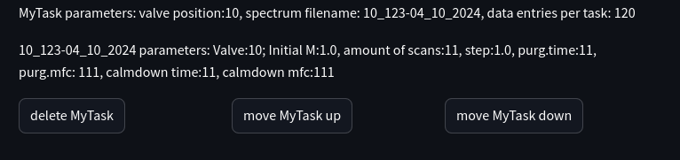

In SpectrumsManager tab, you can view spectrum file parameters:

3) To start data collection, execute StartSampling.py script with superuser privileges. Type admin password as prompted.

cd Desktop/Urania-Main
sudo python3 StartSampling.py

Settings made during set – up process are saved to permanent storage and are not erased when computer is shut down. After computer shutdown, scan may be resumed just by typing commands in point 3.

To stop scanning, use only Ctrl+C hotkey. Usage of Ctrl+Z hotkey leads to an emergency termination of process, and may jam the RGA (it needs to be unjammed through service web page later)

Data visualization

1) To open data visualization page, select the name of desired page on left sidebar. Otherwise, you can navigate to “Currently processed scans” page:

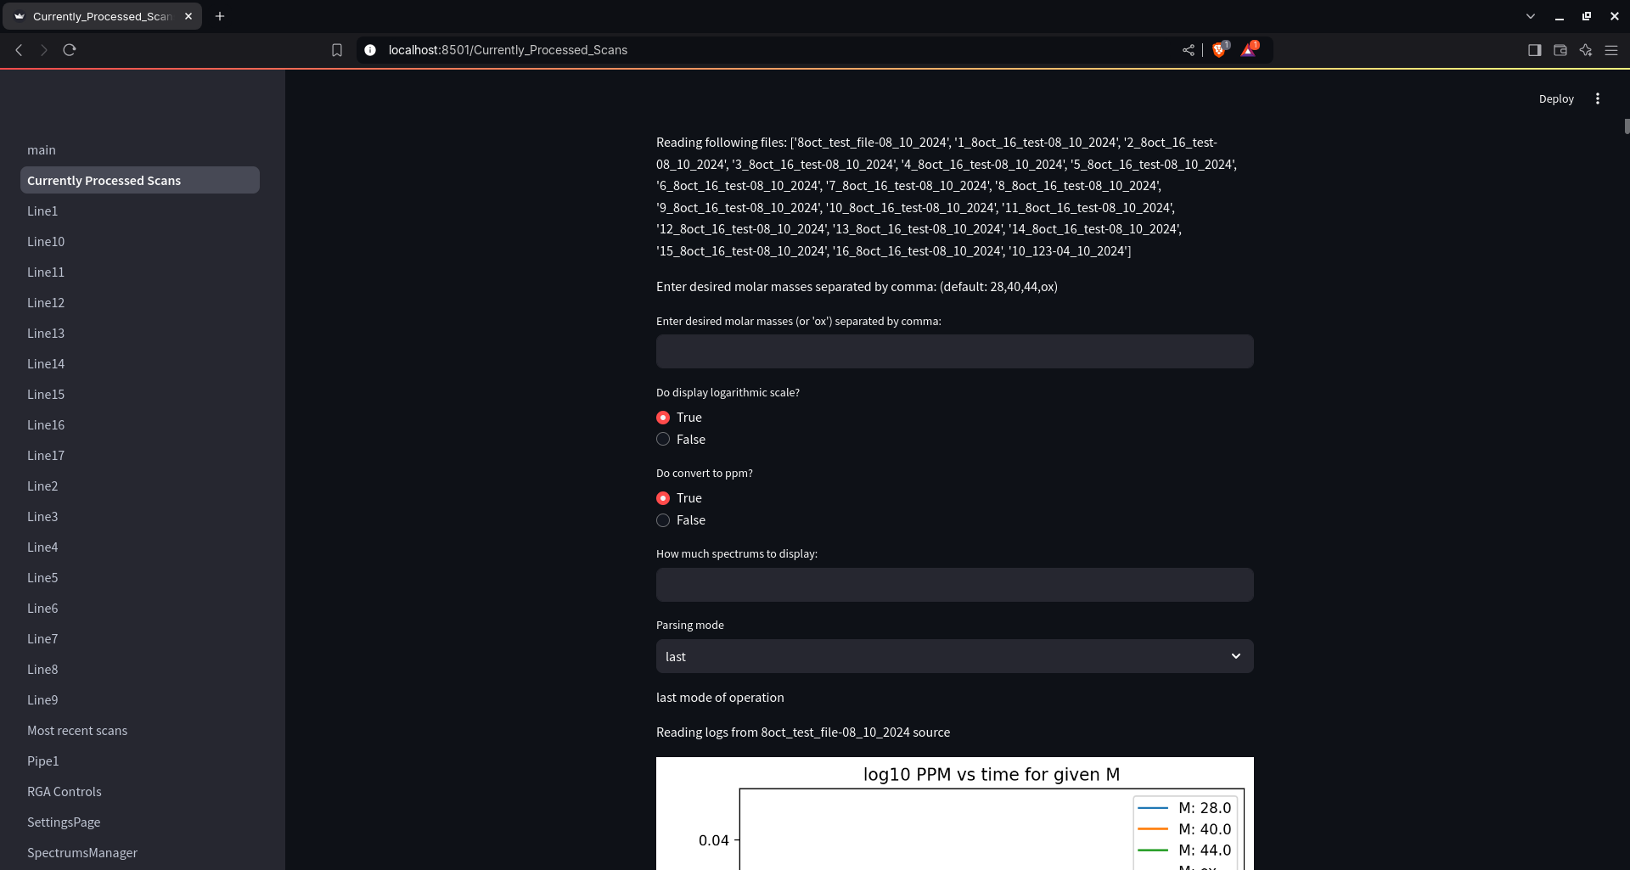

If you go to Line1 page, interface will look like this:

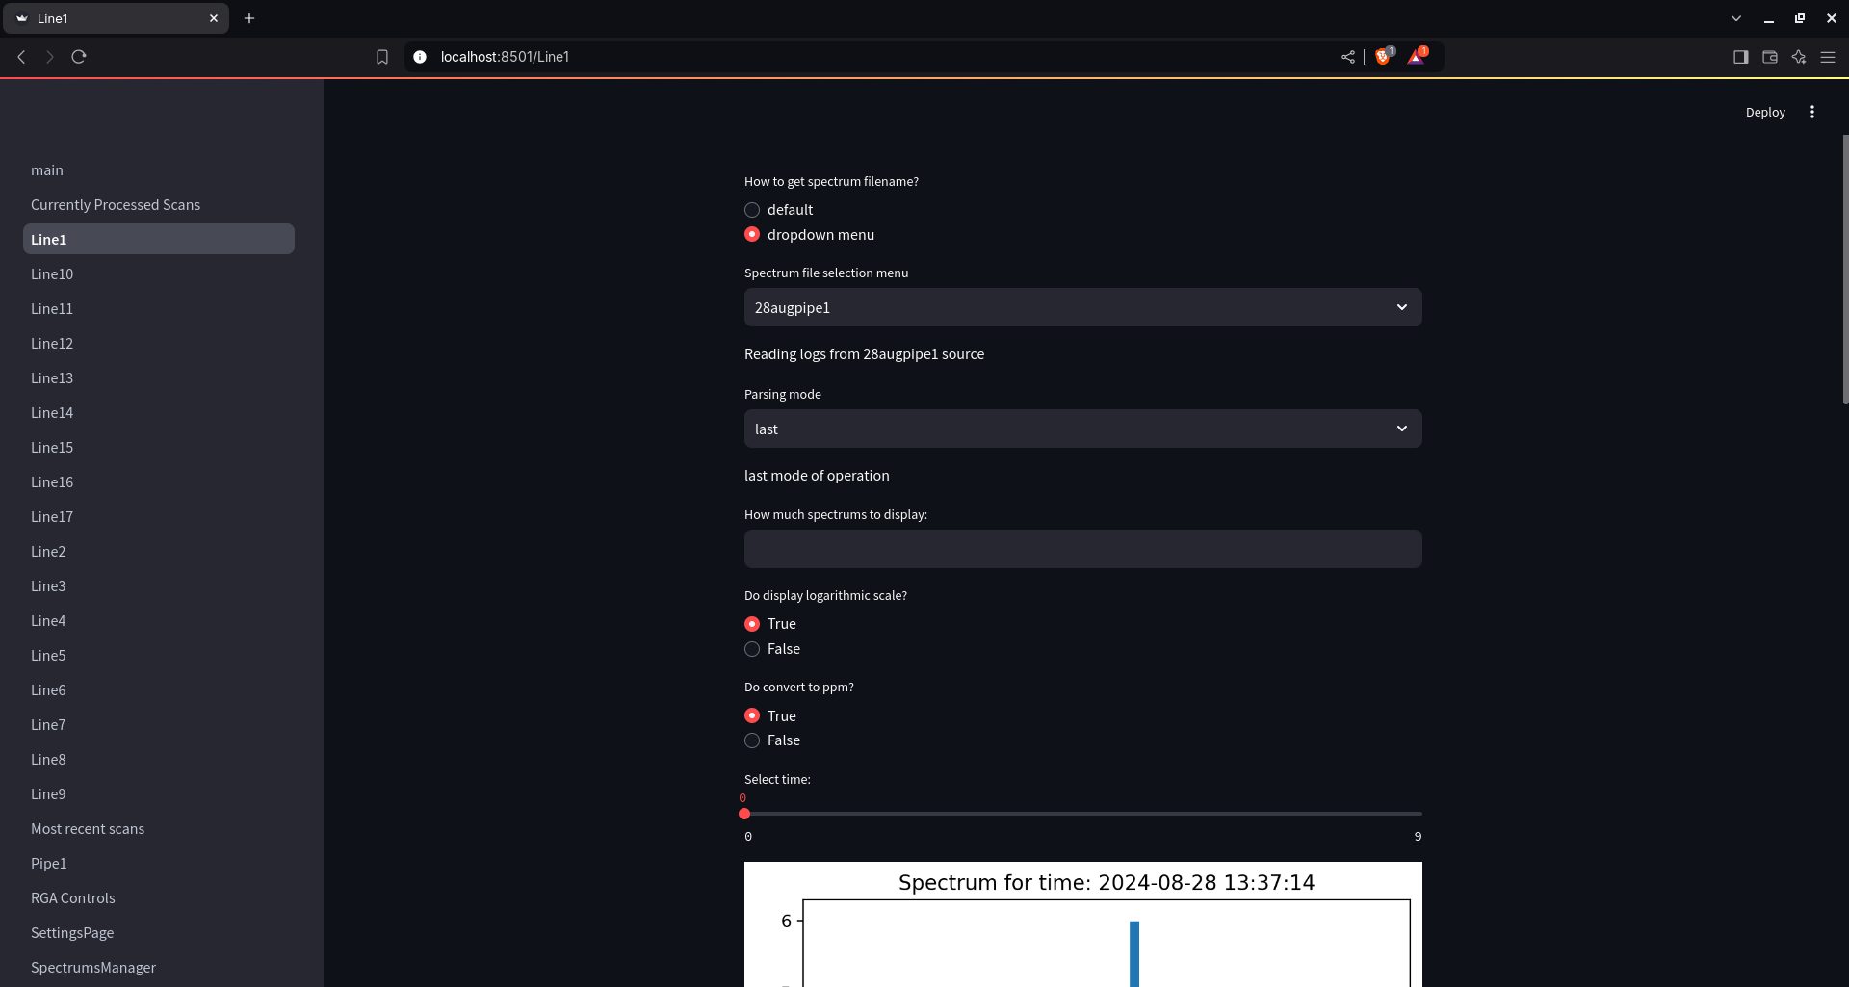

2.0) Select whether you want to process default file or select a “dropdown menu” option and select file from popped up menu.

2.1) Data visualisation works either in “last” or “search” mode of operation. It can be changed in Settings menu. If the mode of operation is “last”, program will automatically display the most recent scans. If the mode of operation is “search”, you should select the date and time through prompted widget. Program will display data for this moment of time

2.2) Select how much spectrums you want to display on screen by typing an integer into the field

2.3) There are two types of graphs displayed below: spectrum for given moment of time and concentration vs time graphs for given molar masses

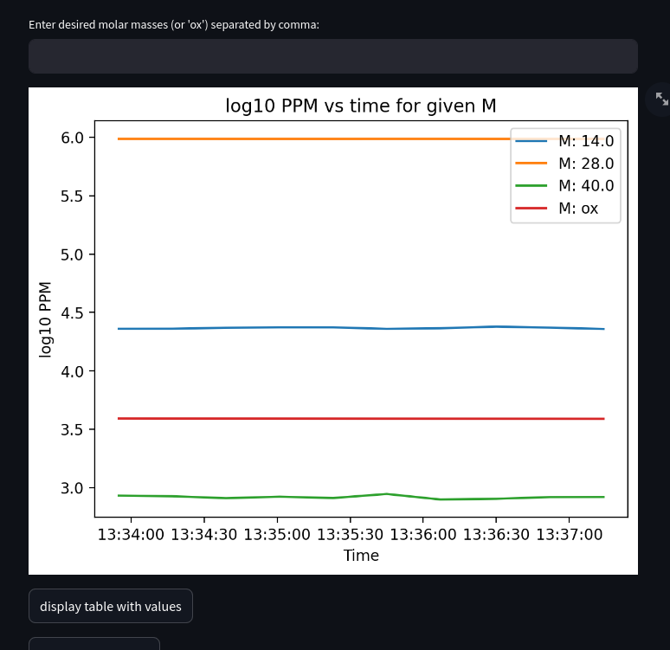
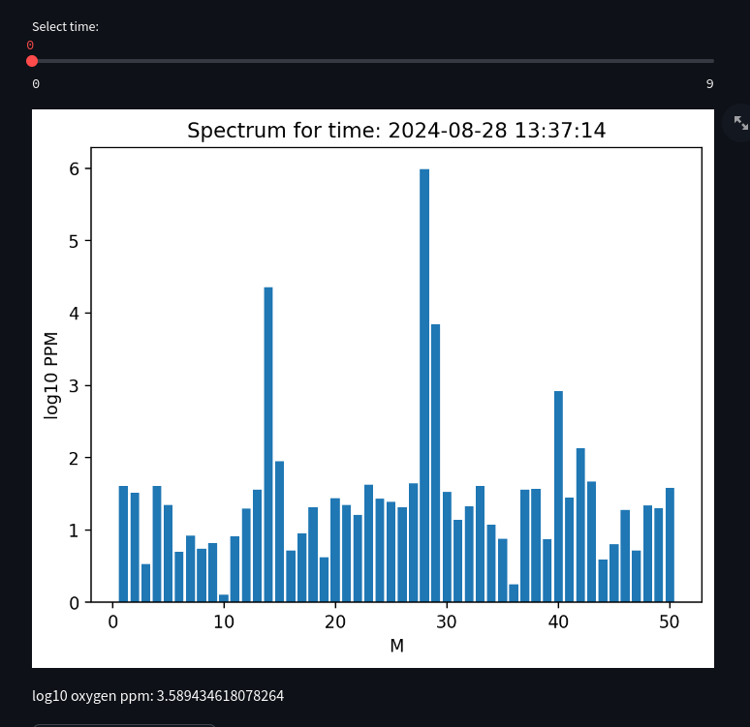

2.4) Each type of graph can be displayed with values in pascals (raw output of RGA) or in PPM (automatically converted). Each type of graph can be displayed either on linear or logarithmic scale.

2.5) For concentration vs time graph, you can input molar masses (or “ox” or oxygen) splitted by comma into the field

2.6) To display table with values (shown from left to right for two different types of spectrums), press “display table with values” button. It can be copied and pasted to office programm such as LibreOffice or Excel
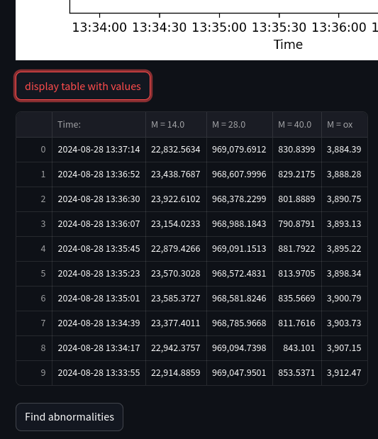
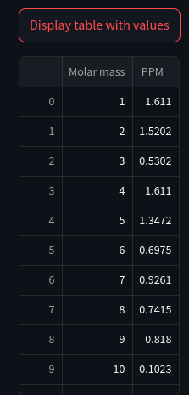

2.7) To compare results with tolerance values (file with tolerances can be selected in Settings), press “Find Abnormalities” button. Not tested yet and not sure if this feature is needed

Remote Access

1) System can be accessed remotely through RustDesk program

1.1) Install RustDesk on your system. On Debian systems it can be done by typing “sudo apt install rustdesk”

1.2) Enter 9-digit ID and password of system (not provided in this manual for security reasons)

1.3) Set up 2FA through any 2FA application (I recommend Aegis, as it is free and open source and 100% offline). Credentials are not provided in this manual

1.4) Click “Remote connect” to control the system or “file transfer” to use system as network attached storage.

Manual control of hardware

1) VSC and multi inlet valve can be controlled using VSC Page page in web app. Web app displays parameters and readings of each sensor and allows user to change them

2) RGA can be manually controlled through RGA Controls page. There are options to control capillary heater; heater and pump in this page

!!! Opening VSC Page while sampling is working may result in sampling program crash/malfunction due to race condition (two processes try interacting with one sensor simultaneously) !!!

Hardware connection setup

1) To discover IP address of RGA, navigate to Technical page and press “Netdiscover RGA IP button”. Computer pings all devices in local network and discovers IP address of RGA

2) To discover location of multi inlet valve; vaccuum system controller and multi inlet valve, unplug them from USB ports and press “Locate devices on USB bus button”. Follow the instructions appearing on the screen

